**TASK # 1 : Design multiple webpages including html and css. Include all the css properties of text, border font e.t.c.**

1. **Home**
2. **Information**
3. **Gallery**
4. **About**

**CODE:**

**Home.html**

<!DOCTYPE html>

<head>

<link rel="stylesheet" href="styles.css">

</head>

<body>

<ul class="navbarul">

<li><a class="active" href="task 1.html">Home</a></li>

<li><a href="Information.html">Information</a></li>

<li><a href="gallery.html">Gallery</a></li>

<li><a href="About.html">About</a></li>

</ul>

<h1>Learn Python</h1>

<p>

Thi website is about learning python. All the free tutorials and snippets will be provided here.

</p>

<h2>

Learn the basics

</h2>

<p>

Learn the Basics

Hello, World!

Variables and Types

Lists

Basic Operators

String Formatting

Basic String Operations

Conditions

Loops

Functions

Classes and Objects

Dictionaries

Modules and Packages

</p>

</body>

</html>

**About.html**

<!DOCTYPE html>

<head>

<link rel="stylesheet" href="styles.css">

</head>

<body>

<ul class="navbarul">

<li><a class="active" href="task 1.html">Home</a></li>

<li><a href="Information.html">Information</a></li>

<li><a href="gallery.html">Gallery</a></li>

<li><a href="About.html">About</a></li>

</ul>

<h1>Learn Python</h1>

<p>Im a student of software engineering currently making the website for learning purpose.</p>

</body>

</html>

**Gallery.html**

<!DOCTYPE html>

<head>

<link rel="stylesheet" href="styles.css">

</head>

<body>

<ul class="navbarul">

<li><a class="active" href="task 1.html">Home</a></li>

<li><a href="Information.html">Information</a></li>

<li><a href="gallery.html">Gallery</a></li>

<li><a href="About.html">About</a></li>

</ul>

<h1>Gallery</h1>

<div class="gallery">

<a target="_blank" href="img_5terre.jpg">

<img src="1.jpg" alt="Cinque Terre" width="600" height="400">

</a>

<div class="desc">dictionary</div>

</div>

<div class="gallery">

<a target="_blank" href="img_forest.jpg">

<img src="2.jpg" alt="Forest" width="600" height="400">

</a>

<div class="desc">Tuples</div>

</div>

<div class="gallery">

<a target="_blank" href="img_lights.jpg">

<img src="3.jpg" alt="Northern Lights" width="600" height="400">

</a>

<div class="desc">Lists</div>

</div>

<div class="gallery">

<a target="_blank" href="img_mountains.jpg">

<img src="4.jpg" alt="Mountains" width="600" height="400">

</a>

<div class="desc">Python for data science</div>

</div>

</body>

</html>

**Information.html**

<!DOCTYPE html>

<head>

<link rel="stylesheet" href="styles.css">

</head>

<body>

<ul class="navbarul">

<li><a class="active" href="task 1.html">Home</a></li>

<li><a href="Information.html">Information</a></li>

<li><a href="gallery.html">Gallery</a></li>

<li><a href="About.html">About</a></li>

</ul>

<p>

<h1>Python programming language</h1>

Python is an interpreted, high-level, general-purpose programming language. Created by Guido van Rossum and first released in 1991, Python's design philosophy emphasizes code readability with its notable use of significant whitespace. Its language constructs and object-oriented approach aim to help programmers write clear, logical code for small and large-scale projects.[28

Python is dynamically typed and garbage-collected. It supports multiple programming paradigms, including procedural, object-oriented, and functional programming. Python is often described as a "batteries included" language due to its comprehensive standard library.[29]

Python was conceived in the late 1980s as a successor to the ABC language. Python 2.0, released 2000, introduced features like list comprehensions and a garbage collection system capable of collecting reference cycles. Python 3.0, released 2008, was a major revision of the language that is not completely backward-compatible, and much Python 2 code does not run unmodified on Python 3. Due to concern about the amount of code written for Python 2, support for Python 2.7 (the last release in the 2.x series) was extended to 2020. Language developer Guido van Rossum shouldered sole responsibility for the project until July 2018 but now shares his leadership as a member of a five-person steering council.[30][31][32]

The Python 2 language, i.e. Python 2.7.x, is "sunsetting" on January 1, 2020, and the Python team of volunteers will not fix security issues, or improve it in other ways after that date.[33][34] With the end-of-life, only Python 3.6.x and later, e.g. Python 3.8 which should be released in October 2019 (currently in beta), will be supported.[35]

Python interpreters are available for many operating systems. A global community of programmers develops and maintains CPython, an open source[36] reference implementation. A non-profit organization, the Python Software Foundation, manages and directs resources for Python and CPython development.

</p>

</body>

</html>

**OUTPUT :**

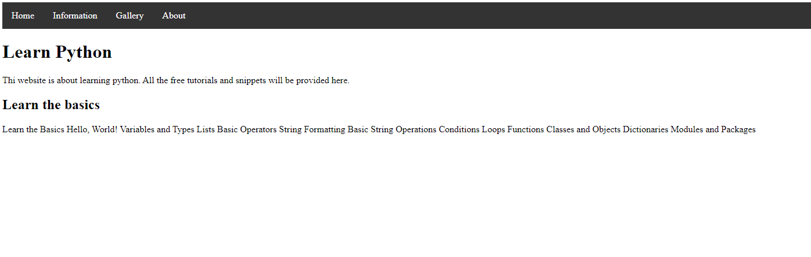

**TASK # 2: Write a css rule that makes all text 1.5 times larger than the base font of the system and colors the text red.**

**CODE:**

body{

font-size: 1.5em;

color:red;

}

**TASK # 3 : Write a css rule that places a background image halfway down the page, tiling it horizontally The image should remain in place when the user scrolls up or down.**

**CODE:**

body {

background-image: url(4.jpg);

background-position: center bottom;

background-repeat: no-repeat;

background-attachment: fixed;

}

**TASK # 4 : Write a css rule that gives all h1 and h2 elements a padding of 0.5 ems, a dashed border style and margin of 0.5 ems.**

**CODE :**

h1,h2{

border-style: dashed;

padding: 0.5em;

margin: 0.5em;

}

**TASK # 5: Add an embedded style sheet to the HTML5 document in the below figure. The style sheet**

**should contain a rule that displays h1 elements in blue. In addition, create a rule that**

**displays all links in blue without underlining them. When the mouse hovers over a link,**

**change the link’s background color to yellow.**

**CODE:**

**Html**

<!DOCTYPE html>

<head>

<link href="task5.css" rel="stylesheet">

</head>

<body>

<h1>

Here are my favorite sites

</h1>

<h3>

Click a name to visit that site

</h3>

<ul class="myul">

<li><a class="mylink" href="#">Facebook</a></li>

<li> <a class="mylink" href="#">Twitter</a></li>

<li><a class="mylink" href="#">Foursquare</a></li>

<li><a class="mylink" href="#">Google</a></li>

</ul>

</body>

</html>

**CSS**

h1{

color: blue;

}

.myul li a{

text-decoration: none;

}

.myul li a:hover{

background-color: yellow;

}

**OUTPUT**:

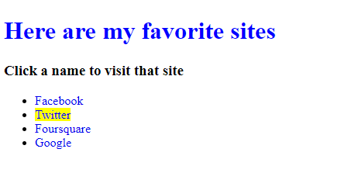

**TASK # 6 : Make a navigation button using a div with a link inside it. Give it a border, background,**

**and text color, and make them change when the user hovers the mouse over the button. Use**

**an external style sheet.**

**CODE:**

**Html**

<!DOCTYPE html>

<head>

<link href="task6.css" rel="stylesheet">

</head>

<body>

<div class="mydiv">

<a href="#">Button</a>

</div>

</body>

</html>

**CSS**

.mydiv a{

background-color: blueviolet;

color: white;

padding: 20px;

border-color: black;

border:3px solid black;

display:inline-block;

margin-top: 20px;

}

.mydiv a:hover{

background-color: red;

color: black;

}

**Output:**

